7 Steps for Successful Basic Primary Cell Isolation
Posted by Luke Doiron on Jul 22, 2015 2:07:36 PM
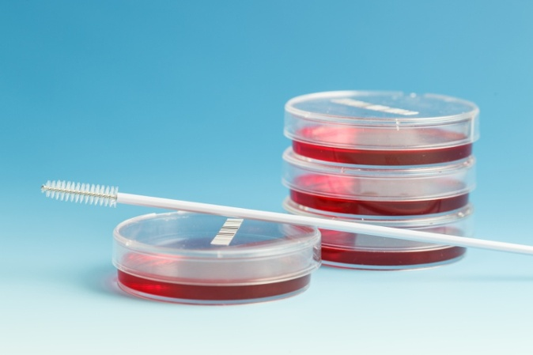
Primary cell isolation is required for subsequent generation of primary cell cultures, which are useful in-vitro tools for pre-clinical disease research. Common applications of primary cell isolates include studies of cellular communication and illumination of disease mechanisms, including cancer, autoimmune diseases, and diabetes.
Primary cells from a biospecimen are typically heterogeneous, so basic cell isolation is used to dissociate and separate the various cell types from tissue specimens. Many researchers believe that primary cells best represent the tumor biology and heterogeneity encountered in the actual clinical environment, and so are worthwhile and important in-vitro models.
When it comes to basic primary cell isolation, it's key to understand that there are a wide variety of parameters that can impact the outcome of any isolation procedure. These include the type of tissue, species origin, specimen age, genetic modification (i.e. knockouts), enzyme type and quality, and incubation time and temperature.
Here are seven important steps often recommended when performing basic primary cell isolation:

1. Use sterile technique
Make sure you harvest and process tissue using sterile equipment, reagents and techniques. Use personal protective equipment as well to avoid contamination. Sterile filter all enzymes and reagents using a 0.22 micron membrane.

2. Mince/cut tissue
Mince or cut your tissue specimen into small pieces (usually 2 x 4mm) with sterile scissors or scalpel, and then place the small pieces into your selected buffer, media or salt solution.

3. Wash and add enzyme
Wash tissue two to three times to eliminate excess blood proteins, then add your enzyme(s) of choice, for example, collagenase, protease, papain or trypsin. Usually about 0.5 to 1.5 mg/ml of your selected enzyme is sufficient.

4. Incubate
Next, incubate tissue specimen in its optimum temperature, typically at 37°C for 30 to 90 minutes. Periodically mix or gently rock specimen.

5. Disperse and wash cells
Now you can disperse cells by gently pipetting them (also known as trituration); then filter cell suspension using a fine mesh. Let the cells settle and decant excess liquid-containing enzymes; wash two to three times. Wash solutions containing FBS, BSA or other inhibitors can also be used to halt enzyme digestion.

6. Resuspend and measure cells
Resuspend cells in the correct medium or buffer and then quantitatively determine your cell yield and viability. This is an important step in the cell isolation process so you can evaluate the result of your dissociation technique. Most researchers use a hemocytometer for determining cell yield and trypan blue diazo dye to measure cell viability.

7. Seed cells
Now you're ready to seed your cells using the plating or processing step you've determined to be the best fit for your research protocol.
A few other important notes:
- When working with cell isolation enzymes, be careful about temperature and humidity conditions. For example, proteolytic enzymes can autolyse so it's recommended that they be immediately dissolved prior to use and stored on ice at 2° to 8° C.
- Most of the enzymes which are typically used for cell isolation can be dissolved directly into a balanced salt solution or buffer of choice.
- For many cell isolation studies, ensuring the tissue survival during dissociation requires that the incubation medium is well oxygenated and buffered at physiological pH. This can be accomplished using a medium equilibrated with a 95% O_{2:}5% CO_{2.}

Our carefully sourced human biospecimens are ideal choices for primary cell isolation studies, and by following the guidelines and suggestions above, you're likely to have high cell yield and viability.

